Week 1: Sample Wireless Network

set ns [new Simulator]

set val(chan) Channel/WirelessChannel;

set val(prop) Propagation/TwoRayGround;

set val(netif) Phy/WirelessPhy;

set val(mac) Mac/802_11;

set val(ifq) Queue/DropTail/PriQueue;

set val(ll) LL;

set val(ant) Antenna/OmniAntenna;

set val(ifqLen) 50;

set val(nn) 2;

set val(rp) AODV;

set val(x) 500;

set val(y) 500;

set topo [new Topography]

$topo load_flatgrid $val(x) $val(y)

set namfile [open out.nam w]

$ns namtrace-all-wireless $namfile $val(x) $val(y)

set tracefile [open out.tr w]

$ns trace-all $tracefile

create-god $val(nn)

$ns node-config -adhocRouting $val(rp) \

-channelType $val(chan) \

-propType $val(prop) \

-phyType $val(netif) \

-macType $val(mac) \

-ifqType $val(ifq) \

-llType $val(ll) \

-antType $val(ant) \

-ifqLen $val(ifqLen) \

-topoInstance $topo \

-agentTrace ON \

-routerTrace ON \

-macTrace OFF \

-movementTrace ON \

set n1 [$ns node]

set n2 [$ns node]

$n1 color black

$n2 color black

$n1 set X_ 200

$n1 set Y_ 100

$n1 set Z_ 0

$n1 set X_ 200

$n1 set Y_ 300

$n1 set Z_ 0

$ns at 0.1 "$n1 color blue"

$ns at 0.1 "$n1 label node1"

$ns at 0.1 "$n2 label node2"

$ns initial_node_pos $n1 30

$ns initial_node_pos $n2 30

proc finish {} {

global namfile tracefile

close $namfile

close $tracefile

exec nam out.nam &

}

$ns at 10.0 "finish"

$ns run

Output:

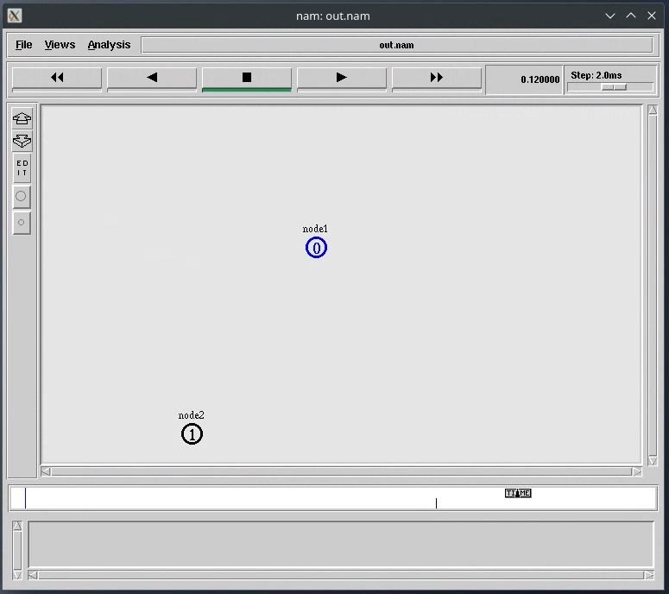

Week 2: Mobile Ad-hoc Network

set ns [new Simulator]

set val(chan) Channel/WirelessChannel;

set val(prop) Propagation/TwoRayGround;

set val(netif) Phy/WirelessPhy;

set val(mac) Mac/802_11;

set val(ifq) Queue/DropTail/PriQueue;

set val(ll) LL;

set val(ant) Antenna/OmniAntenna;

set val(ifqLen) 50;

set val(nn) 3;

set val(rp) DSDV;

set topo [new Topography]

$topo load_flatgrid 500 500

set namfile [open out.nam w]

$ns namtrace-all-wireless $namfile 500 500

set tracefile [open out.tr w]

$ns trace-all $tracefile

create-god $val(nn)

$ns node-config -adhocRouting $val(rp) \

-channelType $val(chan) \

-propType $val(prop) \

-phyType $val(netif) \

-macType $val(mac) \

-ifqType $val(ifq) \

-llType $val(ll) \

-antType $val(ant) \

-ifqLen $val(ifqLen) \

-topoInstance $topo \

-agentTrace ON \

-routerTrace ON \

-macTrace OFF \

-movementTrace ON \

set n0 [$ns node]

set n1 [$ns node]

set n2 [$ns node]

$n0 set X_ 200

$n0 set Y_ 100

$n0 set Z_ 0

$n1 set X_ 200

$n1 set Y_ 250

$n1 set Z_ 0

$n2 set X_ 200

$n2 set Y_ 300

$n2 set Z_ 0

$ns initial_node_pos $n0 30

$ns initial_node_pos $n1 30

$ns initial_node_pos $n2 30

$ns at 1.0 "$n0 setdest 400 110 8"

$ns at 1.0 "$n1 setdest 40 250 8"

$ns at 1.0 "$n2 setdest 430 150 8"

set udp [new Agent/UDP]

set null [new Agent/Null]

$ns attach-agent $n2 $udp

$ns attach-agent $n1 $null

$ns connect $udp $null

set cbr [new Application/Traffic/CBR]

$cbr attach-agent $udp

$ns at 0.1 "$cbr start"

proc finish {} {

global namfile tracefile

close $namfile

close $tracefile

exec nam out.nam &

exit

}

$ns at 12.0 "finish"

$ns run

Output:

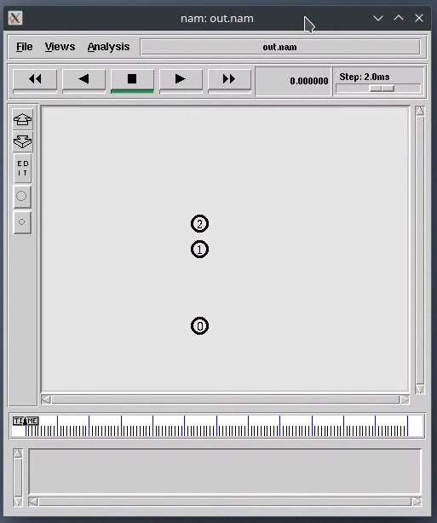 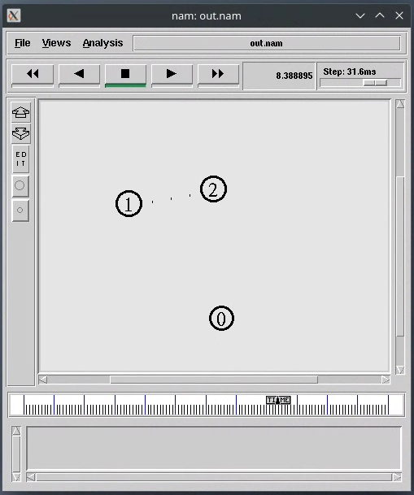

Week 3: Ad-hoc On-demand Distance Vector protocol

set ns [new Simulator]

set val(chan) Channel/WirelessChannel;

set val(prop) Propagation/TwoRayGround;

set val(netif) Phy/WirelessPhy;

set val(mac) Mac/802_11;

set val(ifq) Queue/DropTail/PriQueue;

set val(ll) LL;

set val(ant) Antenna/OmniAntenna;

set val(ifqLen) 50;

set val(nn) 3;

set val(rp) AODV;

set topo [new Topography]

$topo load_flatgrid 500 500

set namfile [open out.nam w]

$ns namtrace-all-wireless $namfile 500 500

set tracefile [open out.tr w]

$ns trace-all $tracefile

create-god $val(nn)

$ns node-config -adhocRouting $val(rp) \

-channelType $val(chan) \

-propType $val(prop) \

-phyType $val(netif) \

-macType $val(mac) \

-ifqType $val(ifq) \

-llType $val(ll) \

-antType $val(ant) \

-ifqLen $val(ifqLen) \

-topoInstance $topo \

-agentTrace ON \

-routerTrace ON \

-macTrace OFF \

-movementTrace ON \

set n0 [$ns node]

set n1 [$ns node]

set n2 [$ns node]

$n0 set X_ 180

$n0 set Y_ 90

$n0 set Z_ 0

$n1 set X_ 60

$n1 set Y_ 30

$n1 set Z_ 0

$n2 set X_ 130

$n2 set Y_ 130

$n2 set Z_ 0

$ns initial_node_pos $n0 30

$ns initial_node_pos $n1 30

$ns initial_node_pos $n2 30

$ns at 1.0 "$n0 setdest 200 350 8"

$ns at 1.0 "$n1 setdest 20 250 8"

$ns at 1.0 "$n2 setdest 430 150 8"

set udp [new Agent/UDP]

set null [new Agent/Null]

$ns attach-agent $n2 $udp

$ns attach-agent $n1 $null

$ns connect $udp $null

set cbr [new Application/Traffic/CBR]

$cbr attach-agent $udp

$ns at 0.1 "$cbr start"

proc finish {} {

global namfile tracefile

close $namfile

close $tracefile

exec nam out.nam &

exit

}

$ns at 12.0 "finish"

$ns run

Output:

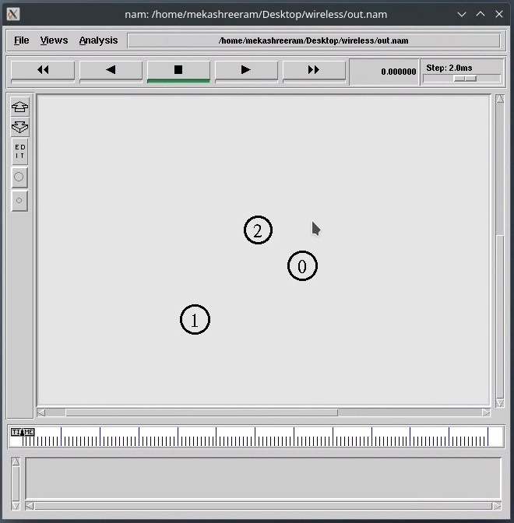

Week 4: Transmission Control Protocol

set ns [new Simulator]

set val(chan) Channel/WirelessChannel;

set val(prop) Propagation/TwoRayGround;

set val(netif) Phy/WirelessPhy;

set val(mac) Mac/802_11;

set val(ifq) Queue/DropTail/PriQueue;

set val(ll) LL;

set val(ant) Antenna/OmniAntenna;

set val(ifqLen) 50;

set val(nn) 4;

set val(rp) DSDV;

set topo [new Topography]

$topo load_flatgrid 500 500

set namfile [open out.nam w]

$ns namtrace-all-wireless $namfile 500 500

set tracefile [open out.tr w]

$ns trace-all $tracefile

create-god $val(nn)

$ns node-config -adhocRouting $val(rp) \

-channelType $val(chan) \

-propType $val(prop) \

-phyType $val(netif) \

-macType $val(mac) \

-ifqType $val(ifq) \

-llType $val(ll) \

-antType $val(ant) \

-ifqLen $val(ifqLen) \

-topoInstance $topo \

-agentTrace ON \

-routerTrace ON \

-macTrace OFF \

-movementTrace ON \

set n0 [$ns node]

set n1 [$ns node]

set n2 [$ns node]

set n3 [$ns node]

$n0 set X_ 200

$n0 set Y_ 100

$n0 set Z_ 0

$n1 set X_ 200

$n1 set Y_ 250

$n1 set Z_ 0

$n2 set X_ 200

$n2 set Y_ 300

$n2 set Z_ 0

$n3 set X_ 100

$n3 set Y_ 270

$n3 set Z_ 0

$ns initial_node_pos $n0 30

$ns initial_node_pos $n1 30

$ns initial_node_pos $n2 30

$ns initial_node_pos $n3 30

$ns at 0.2 "$n0 setdest 89 370 8"

$ns at 0.2 "$n1 setdest 40 250 8"

$ns at 0.2 "$n2 setdest 430 150 8"

$ns at 0.2 "$n3 setdest 60 90 8"

set tcp [new Agent/TCP]

set sink [new Agent/TCPSink]

$ns attach-agent $n2 $tcp

$ns attach-agent $n1 $sink

$ns connect $tcp $sink

set ftp [new Application/FTP]

$ftp attach-agent $tcp

$ns at 0.1 "$ftp start"

set tcp1 [new Agent/TCP]

set sink1 [new Agent/TCPSink]

$ns attach-agent $n0 $tcp1

$ns attach-agent $n3 $sink1

$ns connect $tcp1 $sink1

set ftp1 [new Application/FTP]

$ftp1 attach-agent $tcp1

$ns at 0.2 "$ftp1 start"

proc finish {} {

global namfile tracefile

close $namfile

close $tracefile

exec nam out.nam &

exit

}

$ns at 12.0 "finish"

$ns run

Output:

